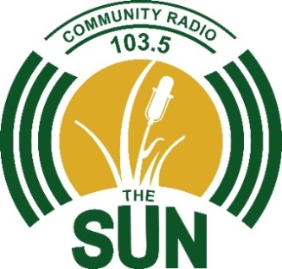
103.5 THE SUN
COMMUNITY RADIO
UNDERWRITING SPECIAL FOR 2018 BEST OF THE MIDWEST MEDIA FEST WINNERS!

Congrats to 103.5 FM’s winning entries in the 2018 Best of the Midwest Media Fest. And thank you for your commitment to excellence by becoming a supporter of these winning programs through underwriting!

- YES! I want to support community radio in Sun Prairie. Please run my underwriting announcements on 103.5 FM The Sun Community Radio before the following programs: Flashpoint, Song Archaeology, Take Immediate Cover, Now You Know, Made in America, Fully Funktional, Council Playback, My World and Welcome To It, Homeroom, Play Anything, and It’s Time for 5. I agree to pay $150/month with a three-month minimum commitment ($450 total).

- YES! I want to support community radio in Sun Prairie. Please run my underwriting announcements on 103.5 FM The Sun Community Radio three times daily (Monday-Sunday) between the hours of 6 AM and 10 PM. I understand that my announcements will be scheduled by 103.5 FM The Sun Community Radio. I agree to pay $200/month with a three-month minimum commitment ($600=270 spots over 3-month period).

- YES! I want to support community radio in Sun Prairie and would like to specify which 103.5 FM The Sun Community Radio program(s) my announcements support. I understand that my announcements will run only before the program(s) I choose and that this agreement covers each airing of the program(s) (currently 2x/week per program). $25/month per program with a three-month minimum commitment.
I understand that my announcements will run only before the program(s) I choose. Program descriptions are available at sunprairiemediacenter.com. Should a program I underwrite be removed from the schedule for any reason, I understand my announcements will continue in conjunction with alternate programming for the term of the agreement.

This agreement is made this __________ day of _______________, 20___ between the Friends of Kids-4, license holder for 103.5 The Sun (WLSP) FM, 1350 Linnerud Drive, Sun Prairie, WI 53590 and:
Business Name:_____________________________________________________ Address:__________________________________________
Phone:_________________________ Website:__________________________________ _________________________________________
Signature:________________________________________________________________ Date:______________________________________
Contract Start Date:________________________________________ Contract End:_______________________________________________
I understand that 103.5 FM The Sun Community Radio retains the right to interrupt or preempt any announcement covered by this agreement at any time in case of emergency or to broadcast other programming if the station feels such change in programming would best advance the station’s community interest mission. I understand every effort will be made to make good preempted or interrupted announcements.
I understand this agreement does not cover announcements missed due to unexpected and unforeseen technical failures or station outages suffered by 103.5 FM The Sun Community Radio.

